Metaltrax Accounting 101

This document goes through the entire accounting process in Metaltrax, beginning with the Purchase Order.
Entering a Purchase Order
When a purchase order is written up, nothing hits the g/l. Let’s begin by writing up a Purchase order for 10 pieces of ¼ Plate at .50/lb. The extended total is $1,633.54 (3267.072 X .50/lb).
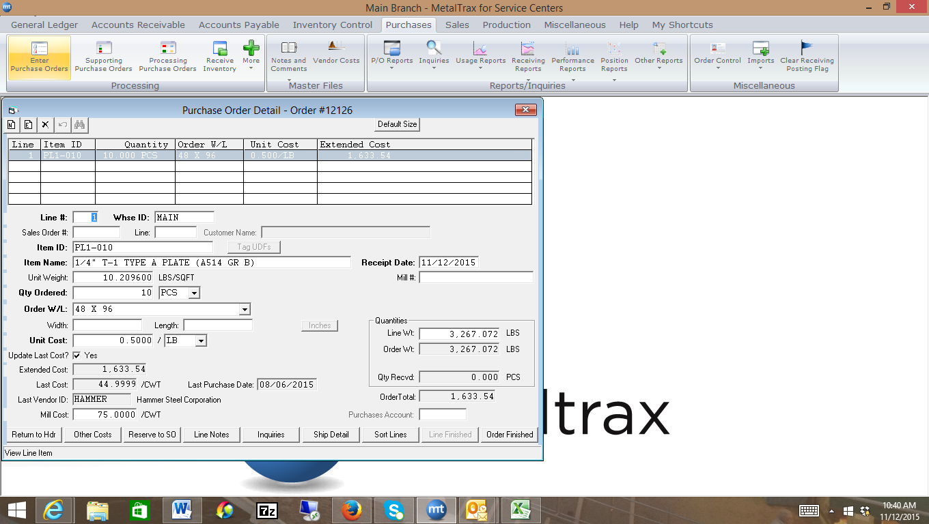
We will now receive in the material.

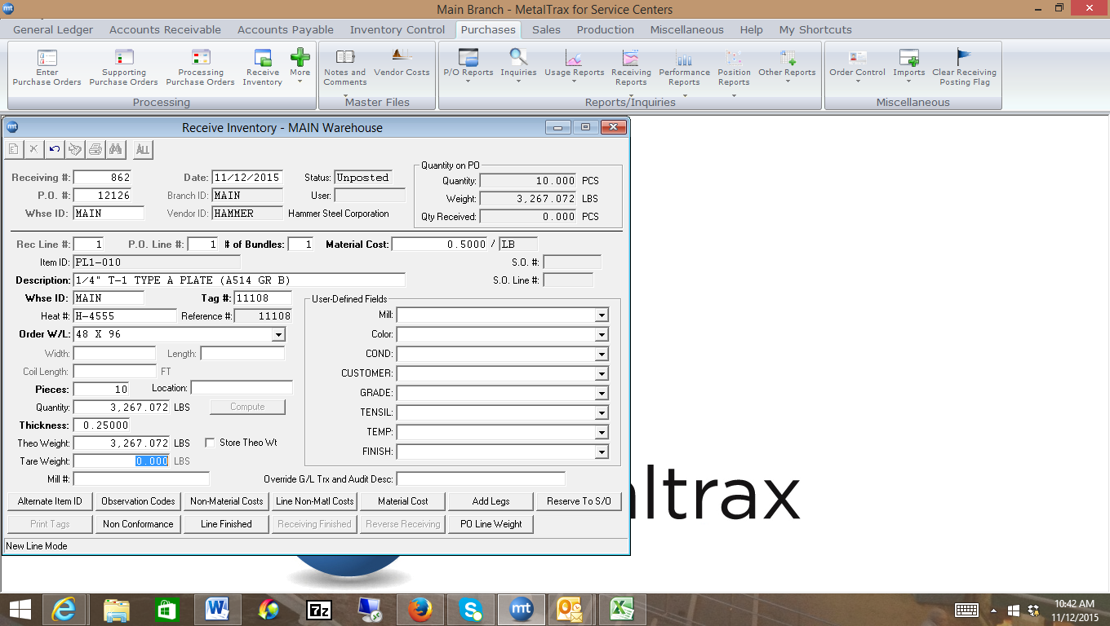
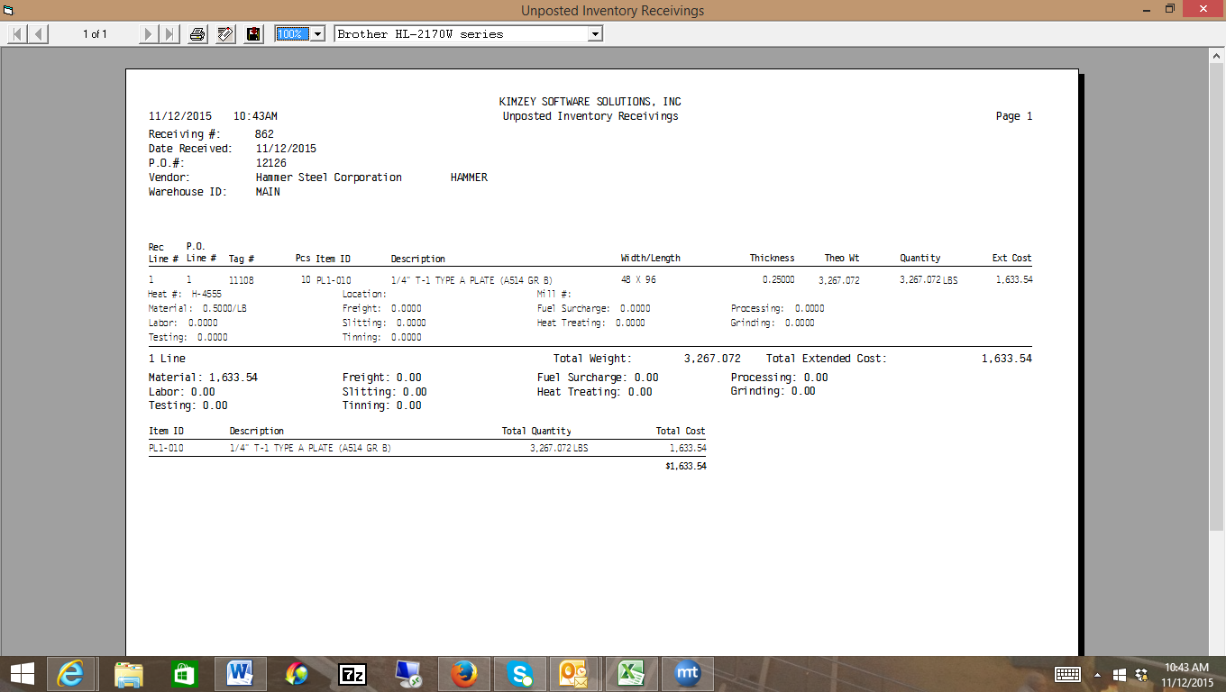
When we post the receiving, the system looks at all the items on the receiving, and the corresponding categories for those items. In this case, there is only one category for the item, and that is PL1. If we look at the G/L accounts for PL1, we see the following. Notice, the Inventory Asset account is 1250. Metaltrax also looks at feature 2000 to see which account is set up as your Pending A/P account. In this case, that g/l account is 3155.

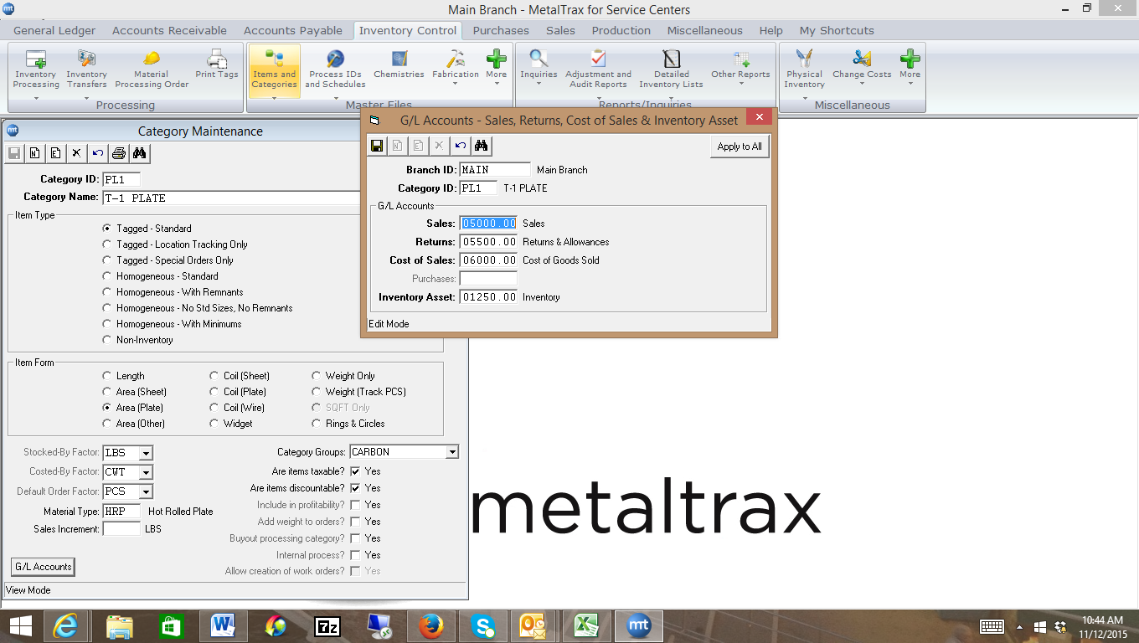

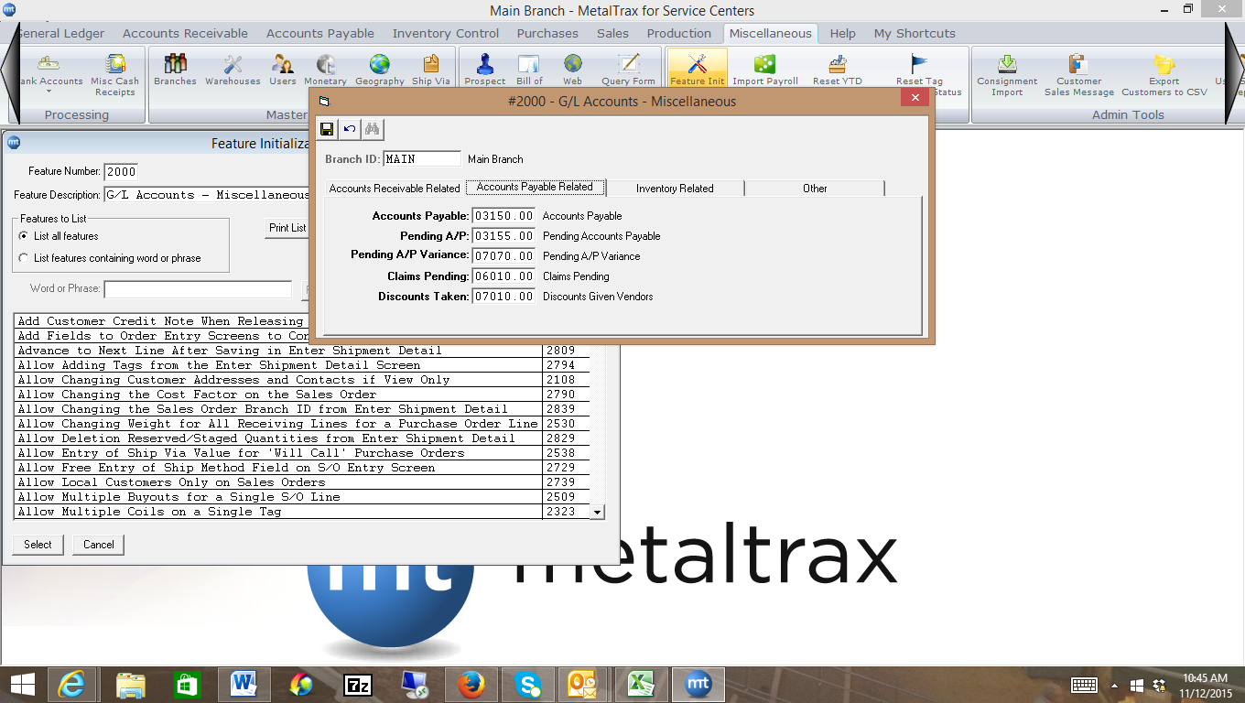
Metaltrax posts a $1, 633.54 debit to the Inventory Asset Account (1250) and a $1,633.54 credit to the Pending A/P account as shown. These are shown in the G/L unposted until the G/L is posted (GLTRX1.DAT) Once the G/L is posted, those exact entries will update the G/L posted file (GLTRANS.DAT).
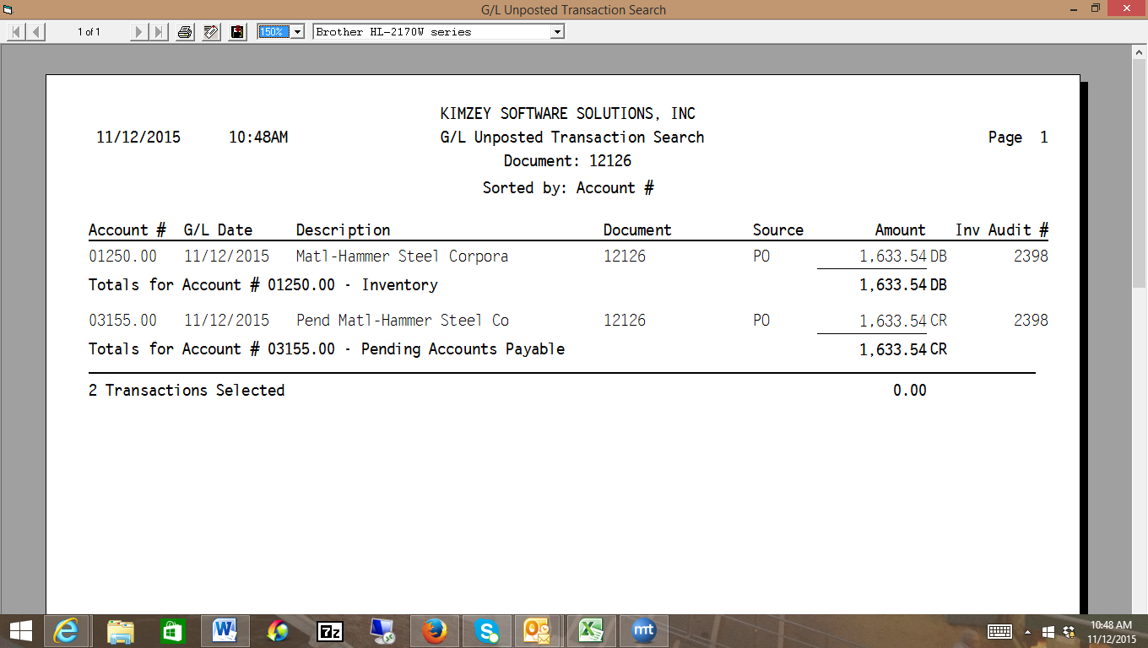
Inputting the PO Invoice
When we receive in the PO Invoice from the vendor (Hammer Steel). Let’s say they invoice you for $1,634. At the top of the Enter PO invoice Page, we input the amount on their invoice, or the $1,634. Notice, when we input the PO at the bottom of the screen, it pulls in our pending of $1,633.54. In this instance, we tell the system we’re being invoiced for $1,634. The system then tells us there is a variance of .46. If you accept that this is correct from the vendor you have two options. You can just clear the variance, or you can tell the system you would like to spread that .46 across any tags on the purchase order before clearing the variance. Let’s do that below by clicking on the Adjust Tag Costs button:
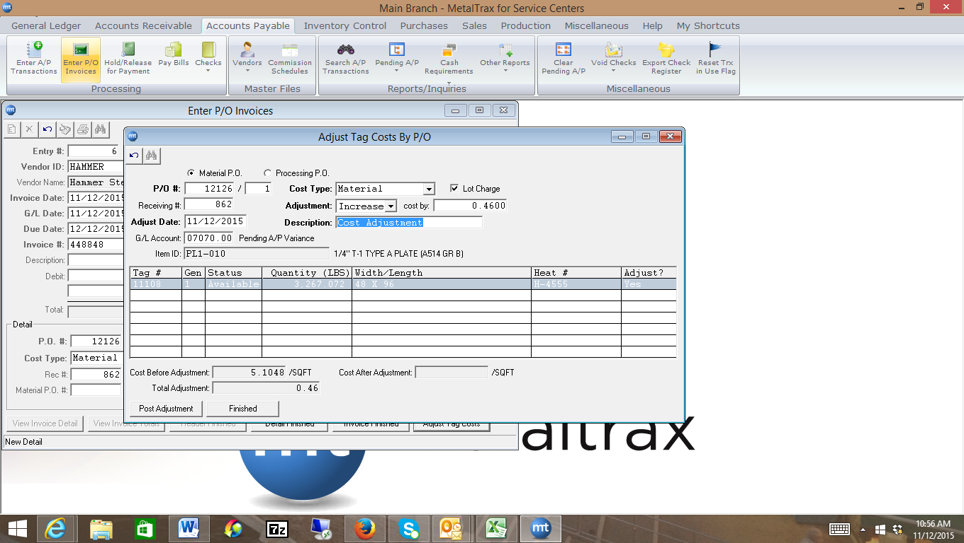
When I’ve adjusted the tag and increased it by .46, I will still need to clear the variance. Metaltrax again goes to look at feature 2000 to see what account I have set up as the Pending A/P Variance account (7070)
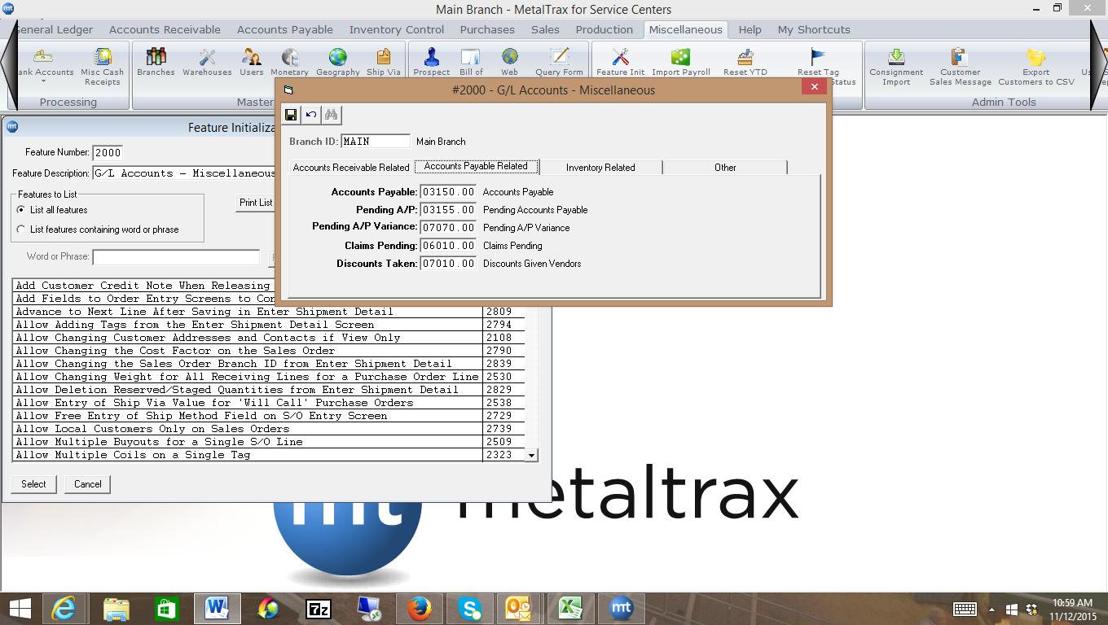
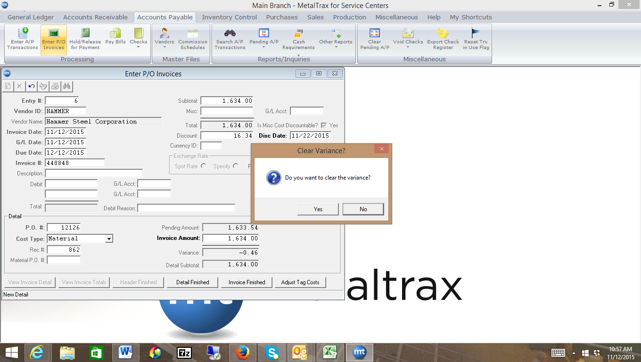
So, I clear the variance then I post. Here’s what happens in the posting process from the A/P side. Notice, the system Credits your A/P account (3150, found in feature 2000), debits out the Pending A/P account (3155) for the entire $1,633.54, leaving .46. The .46 is debited to the Pending A/P Variance Account (7070). Because we also told the system to adjust the tag costs, it Debits the Inventory Asset account (1250) for that tag for .46 and credits the Pending A/P Variance Account (7070) for the .46.
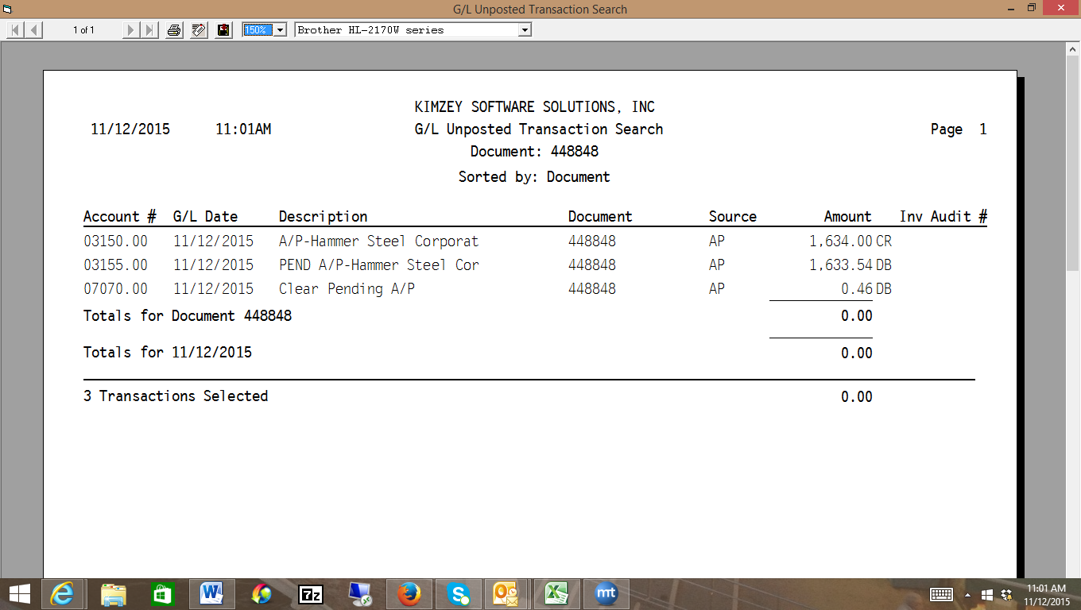
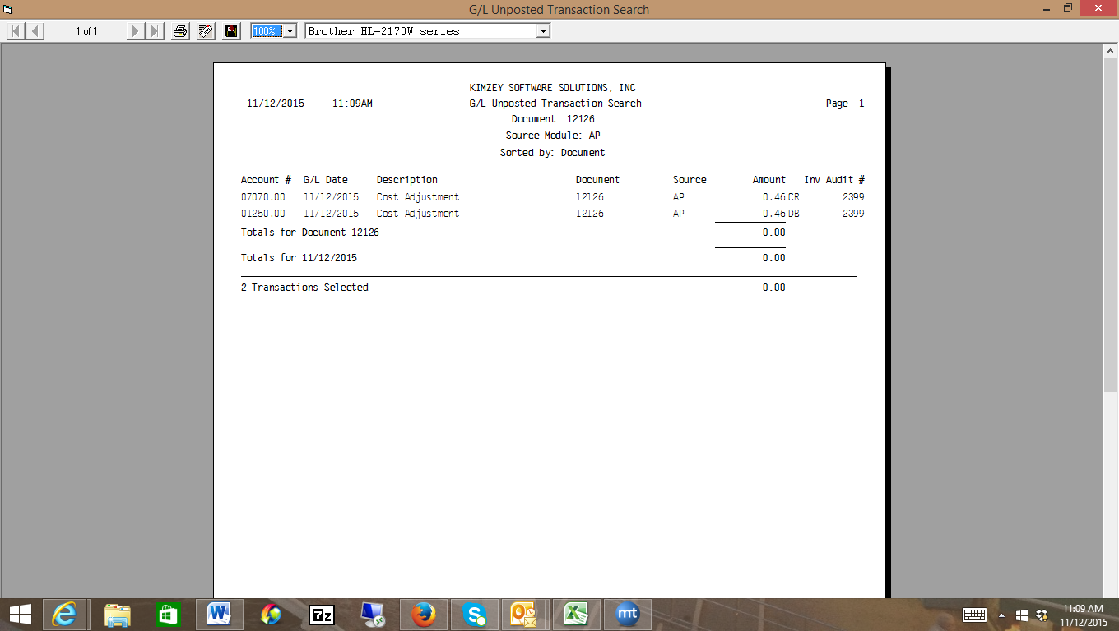
To recap, the net effect on the G/L is a Debit to the Inventory Asset account (1250) for $1,634 and a credit to the A/P account (3150) for $1,634. The other accounts wash.
Making an adjustment to the Inventory

Let’s say you receive in the Purchase order, but instead of typing in .45/lb your user incorrectly types in $45/lb and you don’t catch the error and post. In this case, you could normally just reverse the receiving and it would back it out. However, sometimes you may have already made a small adjustment to the tag, or received in the PO invoice and the system won’t let you reverse the receiving. In this case, you’d have to make some adjustments.
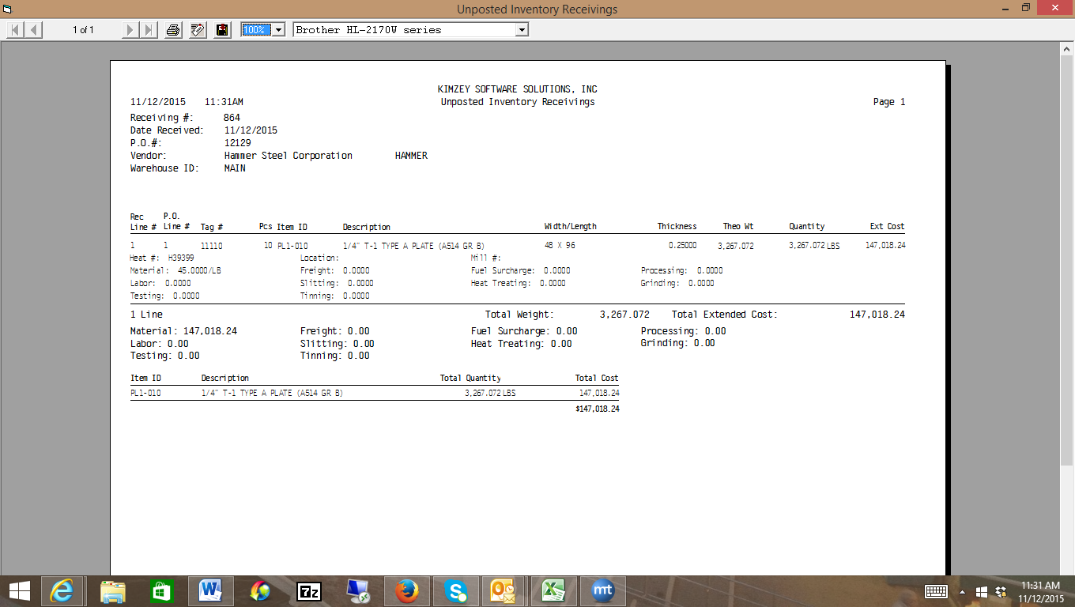
Your inventory asset is currently overstated because you posted a $147,018.24 debit to the inventory asset account (1250) and a $147,018.24 credit to the Pending A/P account also overstates that account. So, we can adjust the tag using the Adjust Tag costs screen, as we did when we were in the Enter PO invoice, or, we can simply pull up the tag in Inventory Inquiry and adjust it, as shown below. When prompted for the offset account, we would use the Pending A/P Variance account (7070), as shown below:
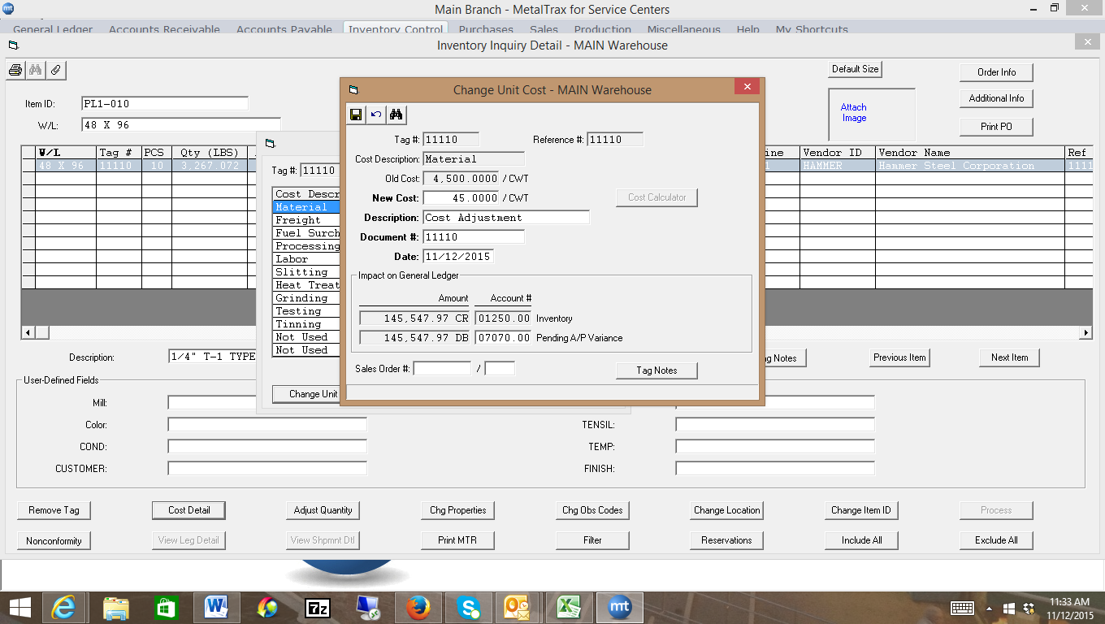
When you post this adjustment, the G/L entries would be as follows: Notice, there is a credit to the Inventory Asset account (1250) of $145,547.97 (and a debit to the Pending A/P Variance account (7070) of $145,547.97 ($147,018.24-$1,470.27). At this point, the inventory asset account is all correct, but there is still an amount debit amount in that Pending A/P Variance account. We’ll see how to get rid of that next.
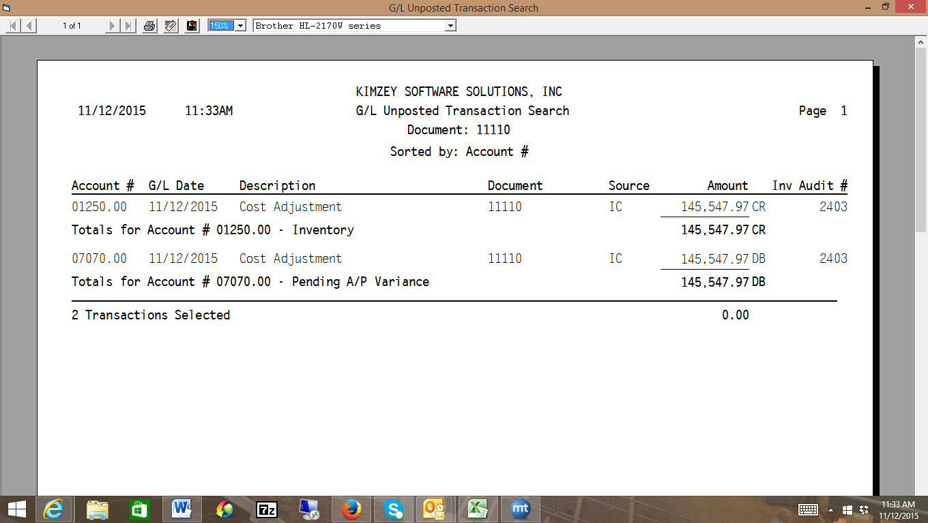

You also still have the additional amount showing a credit in your pending A/P file. So, when your Invoice clerk does the invoice, and it’s only for the correct amount of $1470.27, the pending amount is going to pull up as shown:
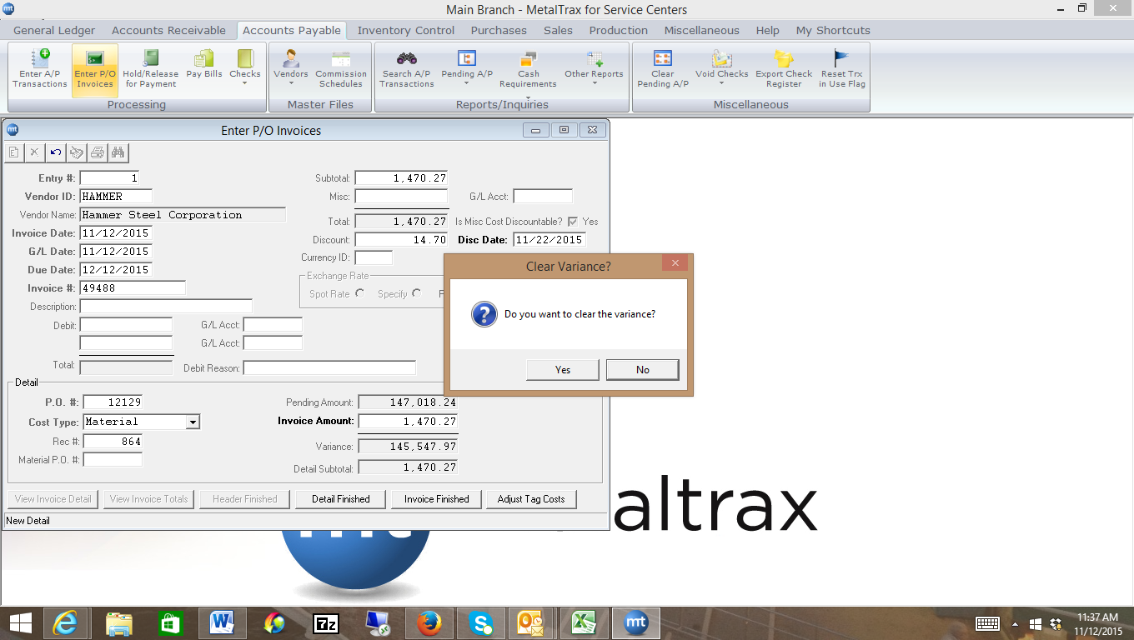
When you clear the variance, the system will Credit the A/P account (3150) for $1,470.27 because that is the amount of the invoice. It will then Debit out the Pending A/P account for the $147,018.24, leaving a zero balance in the Pending A/P account. It will also Credit out the Pending A/P Variance account (7070) for the $145,547.97, leaving a zero balance in that account as well.

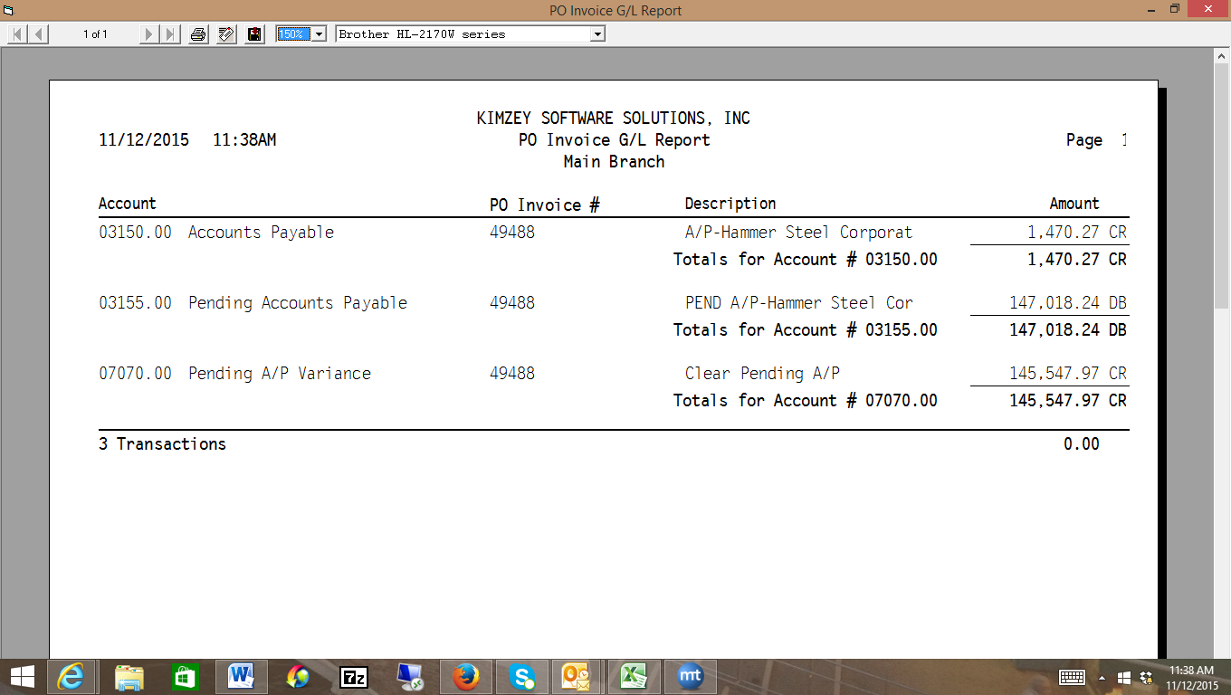
Returning Material to a Vendor
When you receive in Material that is bad, you’ll want to email the vendor a non-conformance sheet at the time of the receiving to make a claim against the material. When the vendor gives you a credit, that is considered a debit in Metaltrax. So, let’s say a piece of that ¼ Plate we received in on PO 12126 was bad. You can input a debit memo into the system, or you can remove the inventory, it doesn’t matter which comes first. Let’s assume you remove the inventory first.
Go to the inventory inquiry screen, type in the tag or lookup the item and find the tag. When you’ve pulled up the tag, click on the Adjust Quantity tab. In our scenario, we are going to adjust the tag from 10 pieces to 9 pieces. The system will automatically credit the inventory asset account (1250) found on the inventory category g/l screen that corresponds to the item. When prompted for the offset, use the Claims Pending Account found in feature 2000 (6010). You will now have a Debit in your Claims Pending account (6010) of $163.40, until the vendor sends you the credit (debit memo).
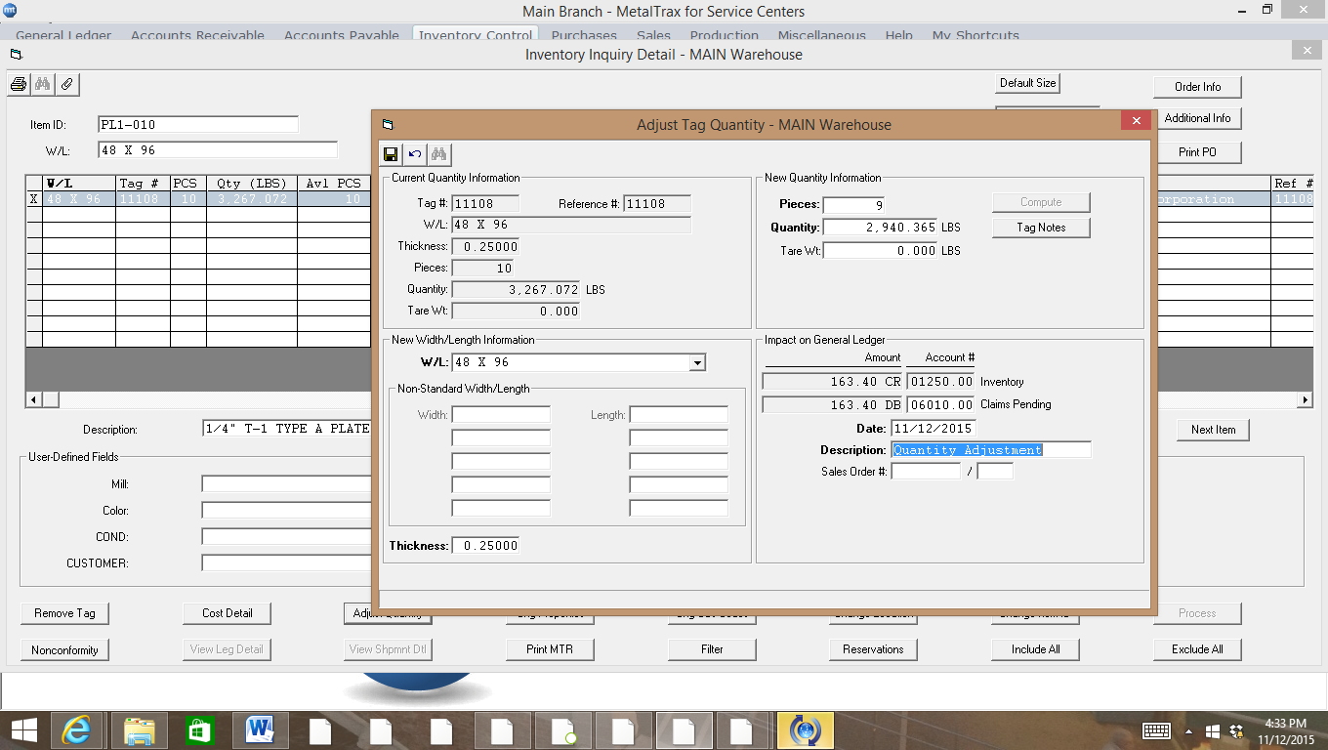
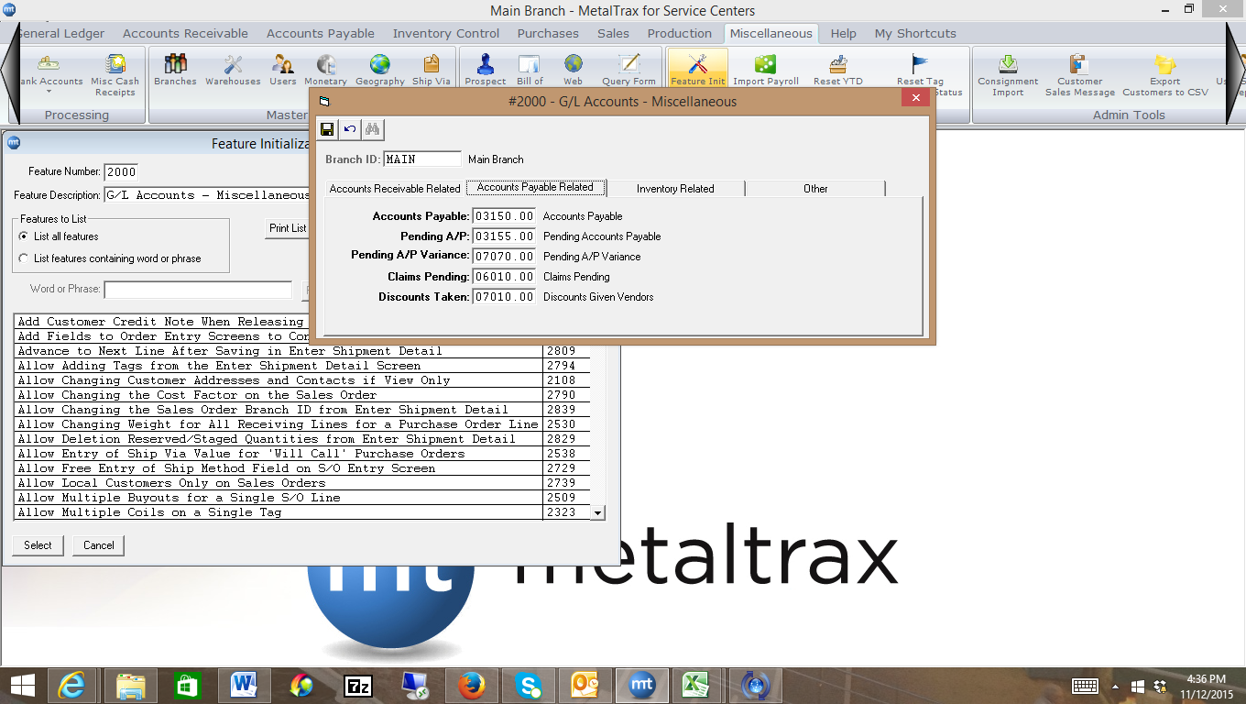
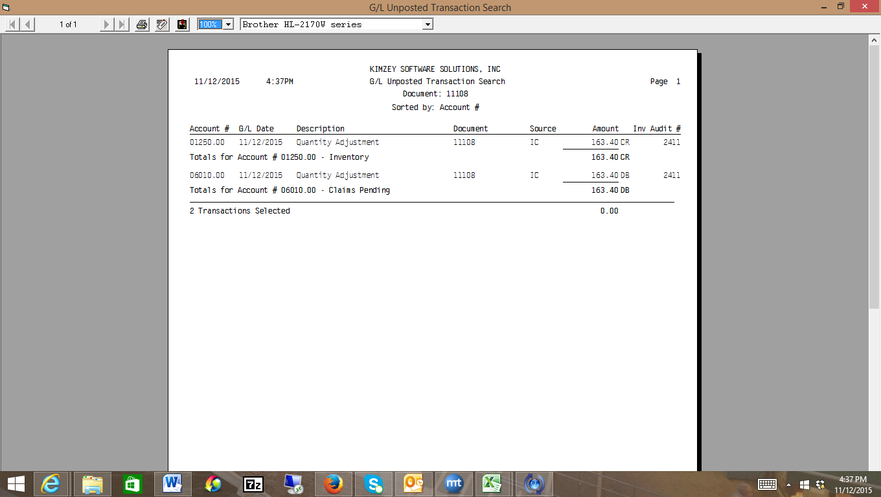
Entering the Debit Memo
When the vendor sends you the credit, go to Purchases, Processing, More, Enter Debit Memos, type in the date and the receiving number, and click on header finished. Put in the line number and the number of pieces the vendor is crediting you for. The system will debit the Accounts Payable account (3150) for $163.40 and credit the Claims Pending Account (6010) for $163.40.
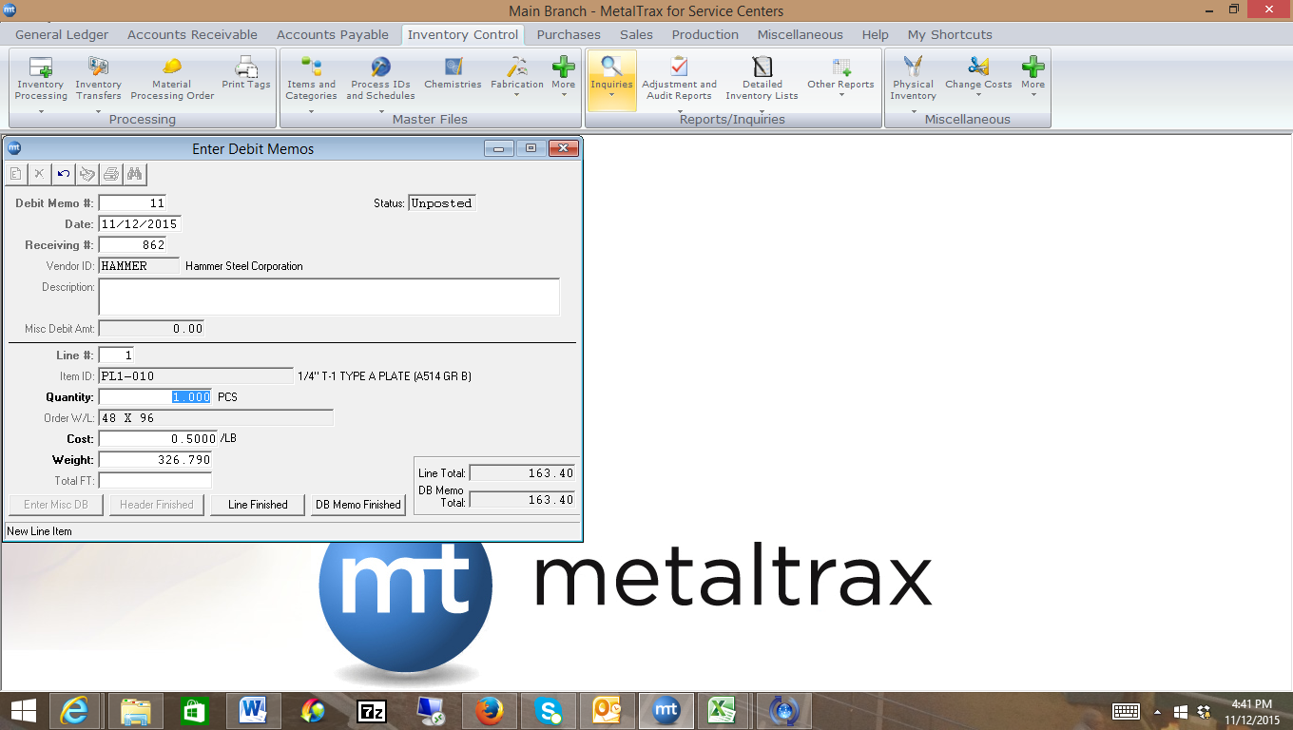
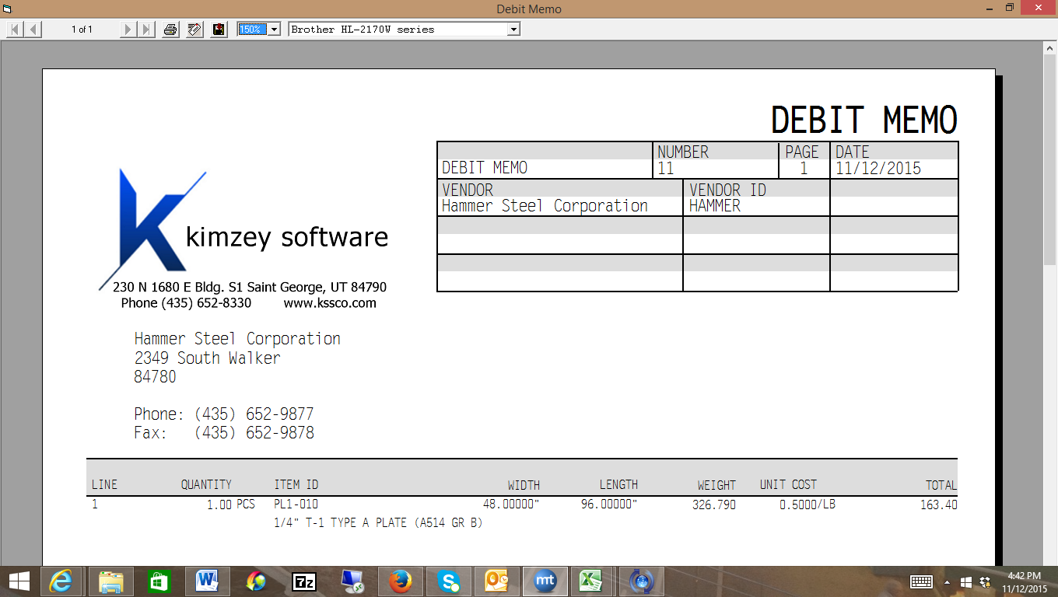
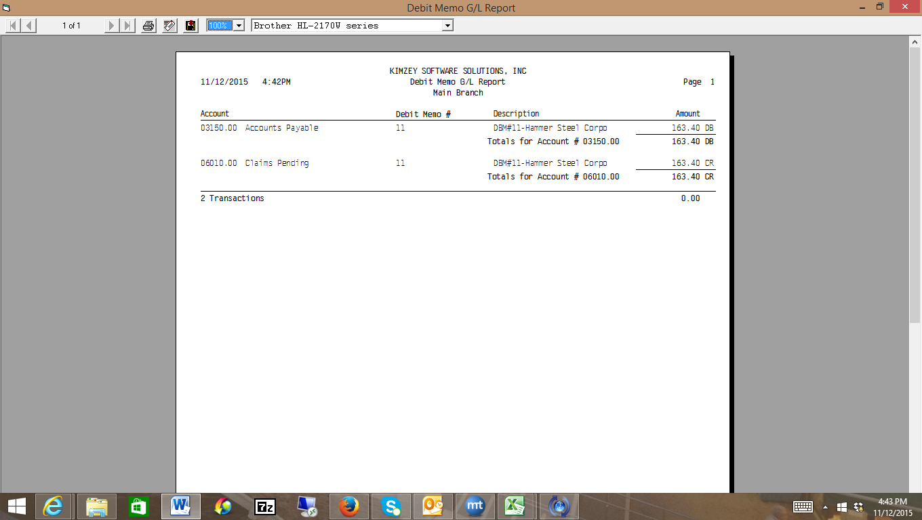
Entering an Accounts Payable Payment
To pay a Vendor invoice, we’re going to go into the Bill Pay screen, as shown below. In our example, we’re going to pay invoice 1234 for $200, and invoice 13872 for $14,962.35 but we’re also applying a 1% discount to that invoice for $149.62, so the total amount to pay is $14,812.73.
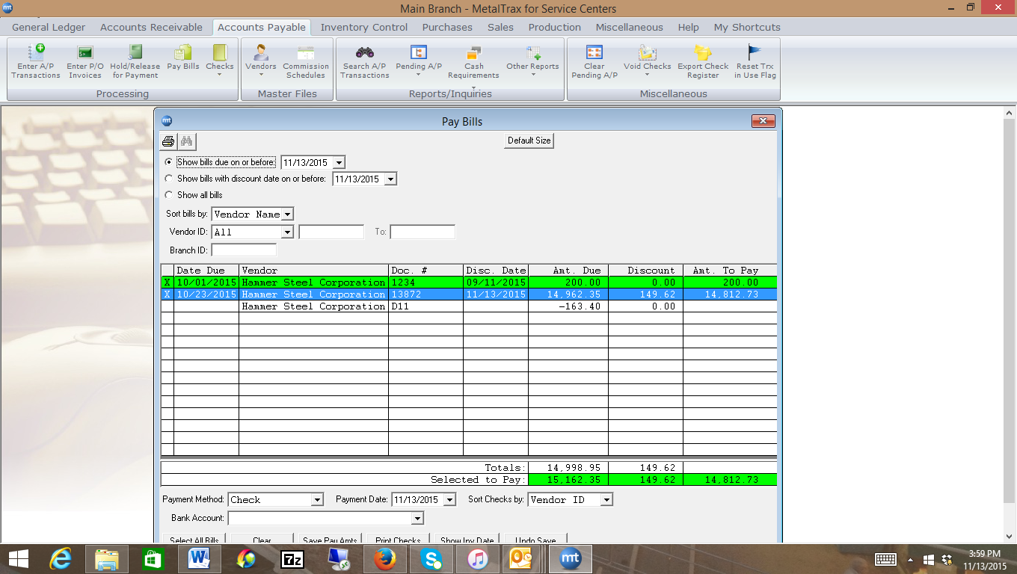
Metaltrax credits the Cash in Bank (1010) account for $15,012.73, debits the Accounts Payable account (3150) for $15,162.35, and credits the Discounts Given to Vendors account (7010) for the discount amount of $149.62. The Discounts Given to Vendors is setup in feature initialization 2000 under the Accounts Payable Tab for Discounts Taken.
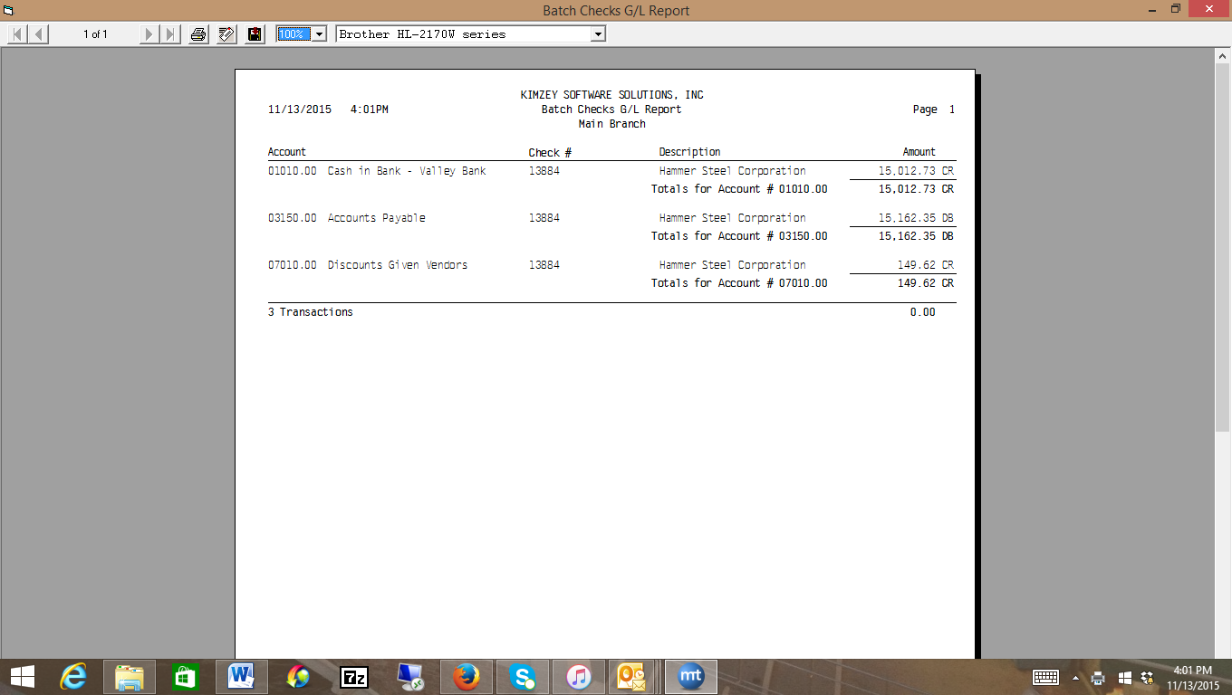
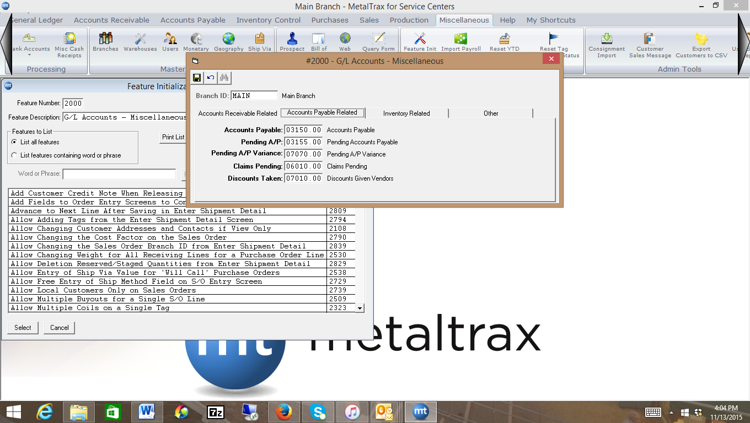
Sales Invoice
When you put in a sales order, nothing happens to the G/L. However, we will input a sales order and go through the entire process, so we can see what happens when the sales order is invoiced.
We’ll begin by putting in a sales order for 5 pieces of ½ Cold Finished Bar. We’ll also make the order taxable. The total on the order is $36.85, plus $2.95 for sales tax, for a total of $39.80

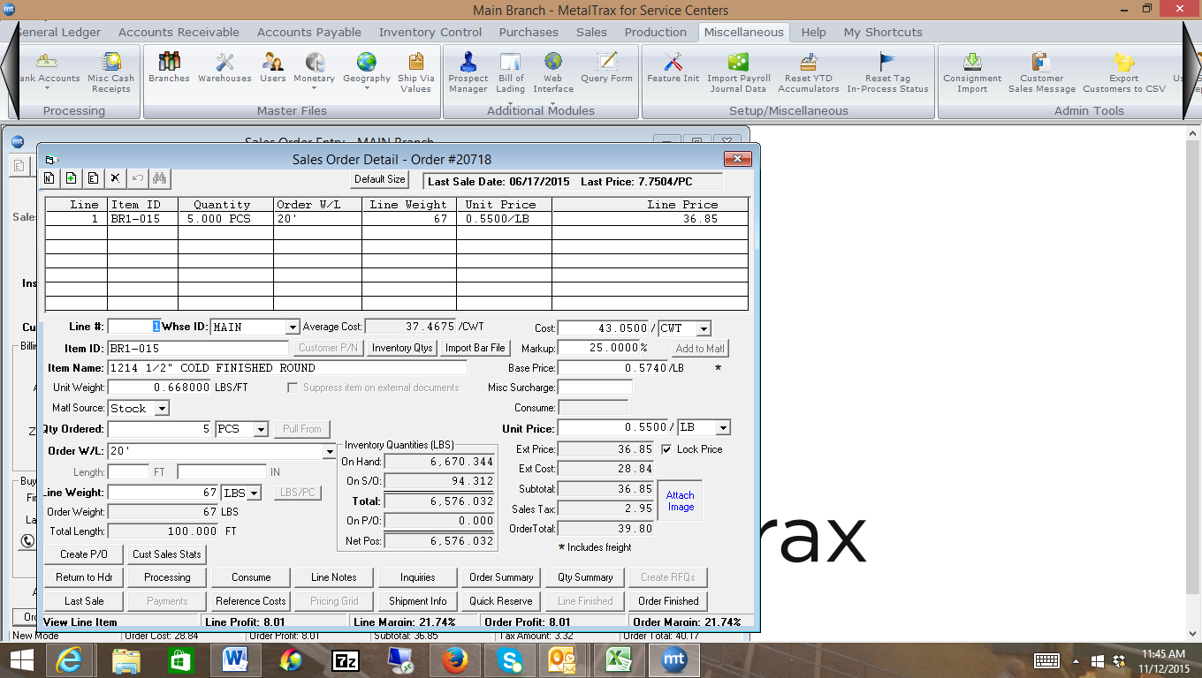
When we pull the inventory, I’m going to pull 5 pieces that are .40/lb. To do this, I’m going into Shipment detail and pull 5 pieces off of tag 10880, and ship 5 pieces. At this point, there is still nothing that hits the G/L.
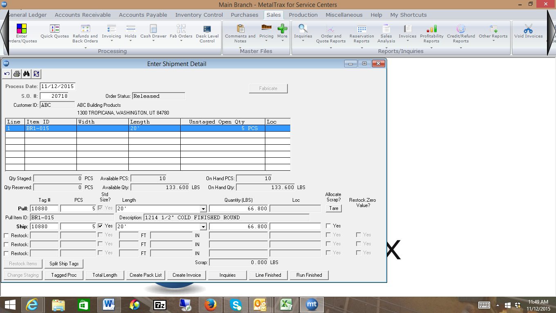
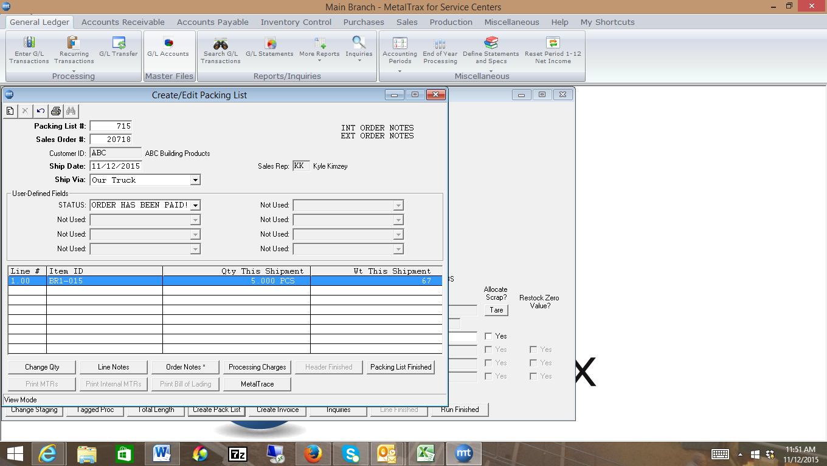
I then create the Packing list, and still, nothing updates the G/L. It’s now time to create the invoice. Once I create the invoice, I can print the invoice, but nothing updates the G/L until after I post the invoice.
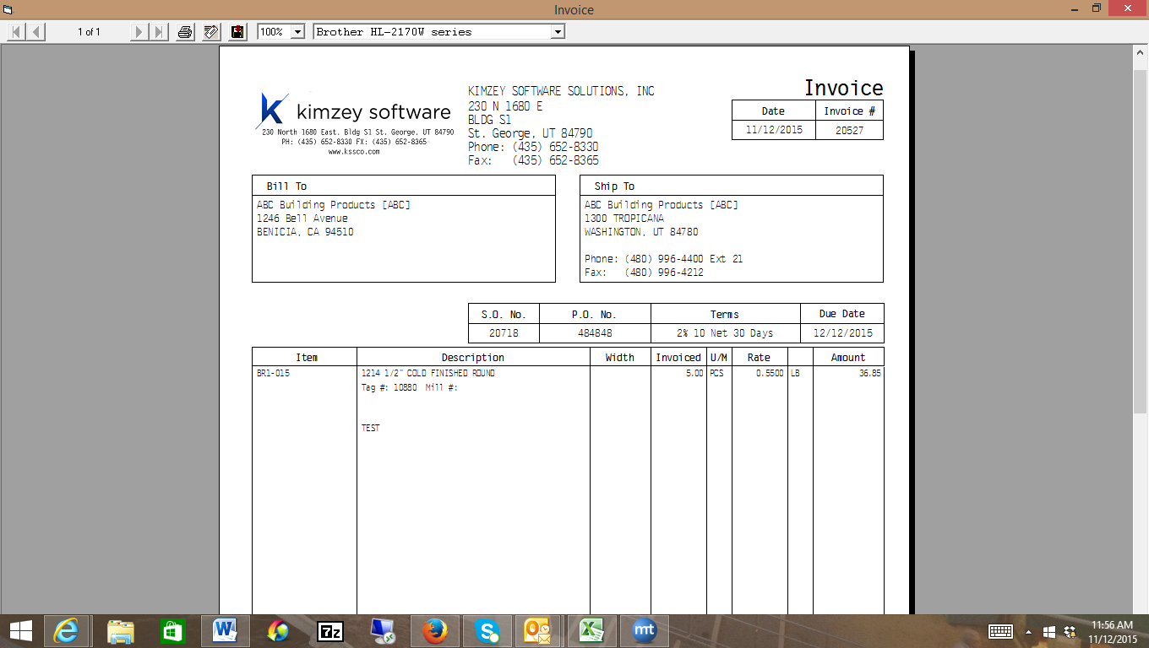

Once I post the invoice, the following occurs: The system looks at the category for each item on the invoice, and looks at the Sales account (5000), inventory asset account (1250) and cost of good sold account (6000) for each item. It also checks which account is the A/R account for the branch you are logged into (feature 2000) and if there is sales tax on the order, it checks the appropriate sales tax payable account (3160) from the Sales Tax Code Maintenance screen.
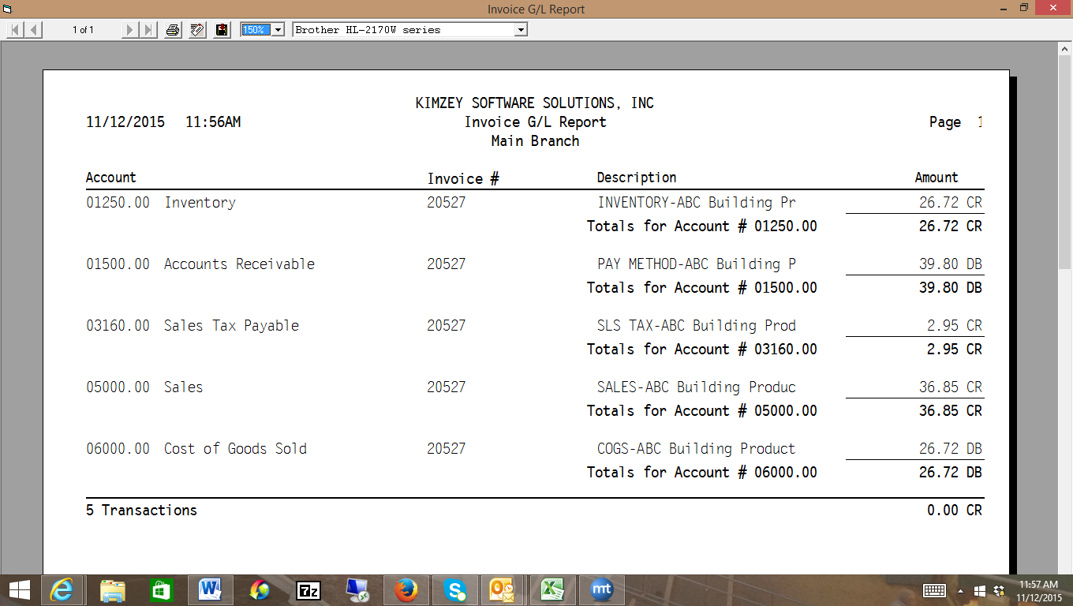
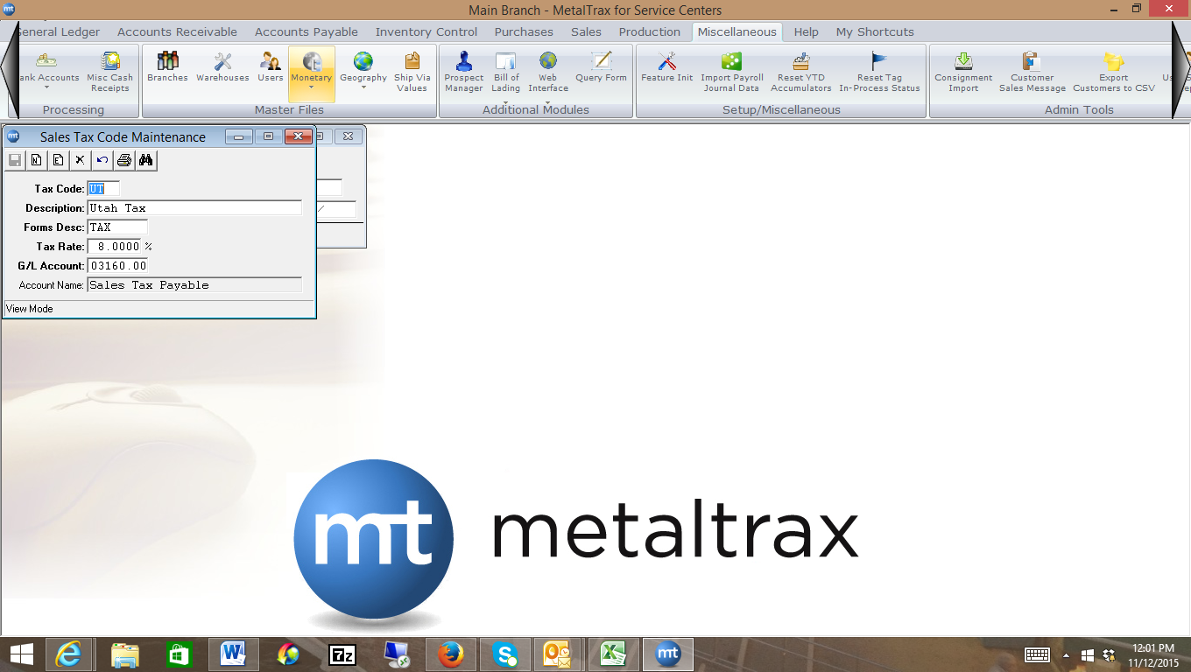
Notice, there is a credit to the Inventory Asset account (1250) for $26.72, a debit to the Accounts Receivable account (1500) for $39.80, a credit to the Sales Tax Payable account (3160) for $2.95, a credit to the sales account (5000) for $36.85, and a debit to the Cost of Goods Sold Account for $26.72.
Entering a Credit Memo
First, see how the user has set up the restock options in feature initialization # 2745. I’ll first show you how the system handles it when the feature is set to “No, you don’t want Metaltrax to return the tags to stock automatically. In this case, let’s say the customer returns three (3) of the pieces from invoice 20527.
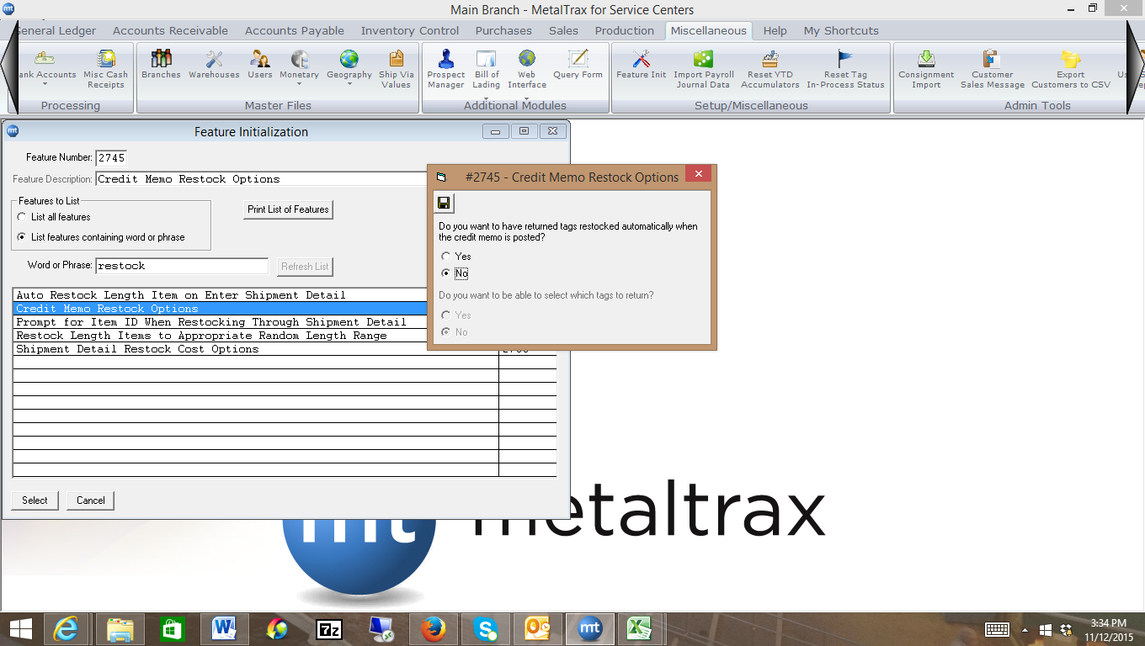
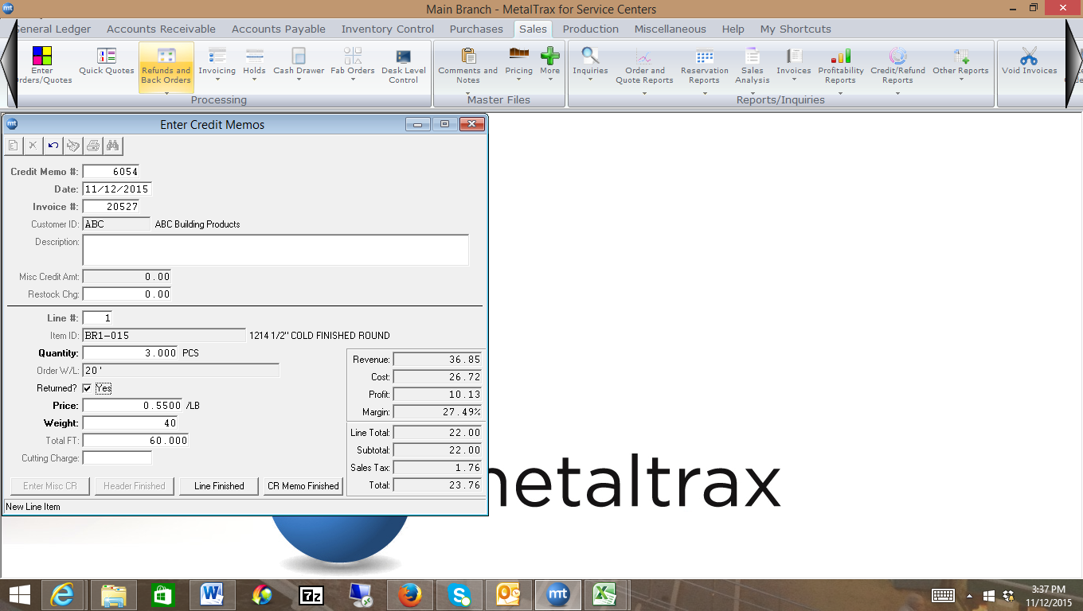
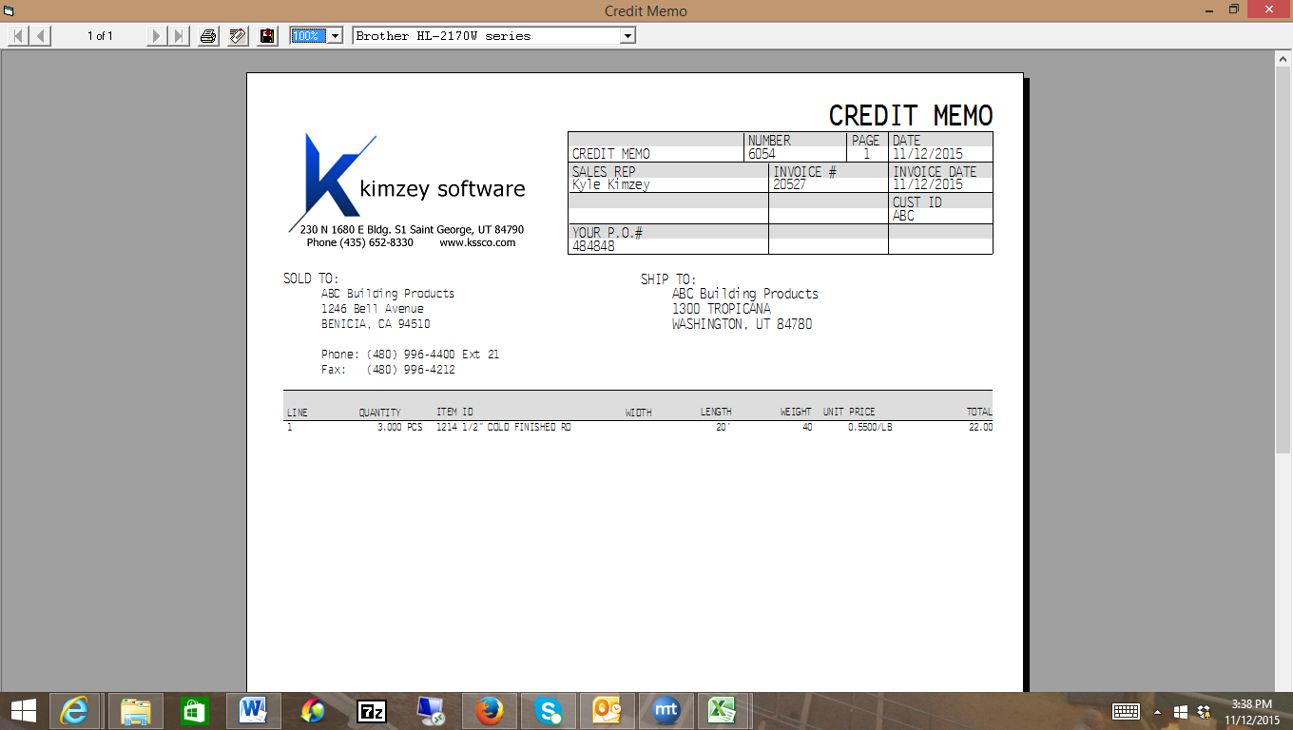

When we post the credit memo, here’s what happens to the G/L accounts. Metaltrax debits the Credit Memo Holding account that was setup in feature 2000 as shown below. A credit of $23.76 is made to the Accounts Receivable account (1500). A Debit for a portion of the sales tax, $1.76, is made to the Sales Tax Payable account (3160). The Returns and Allowances Account (5500) that is setup under the category G/L accounts is debited for $22.00 and the Cost of Goods Sold Account (6000) that was setup under the category G/L accounts is Credited for $15.95.

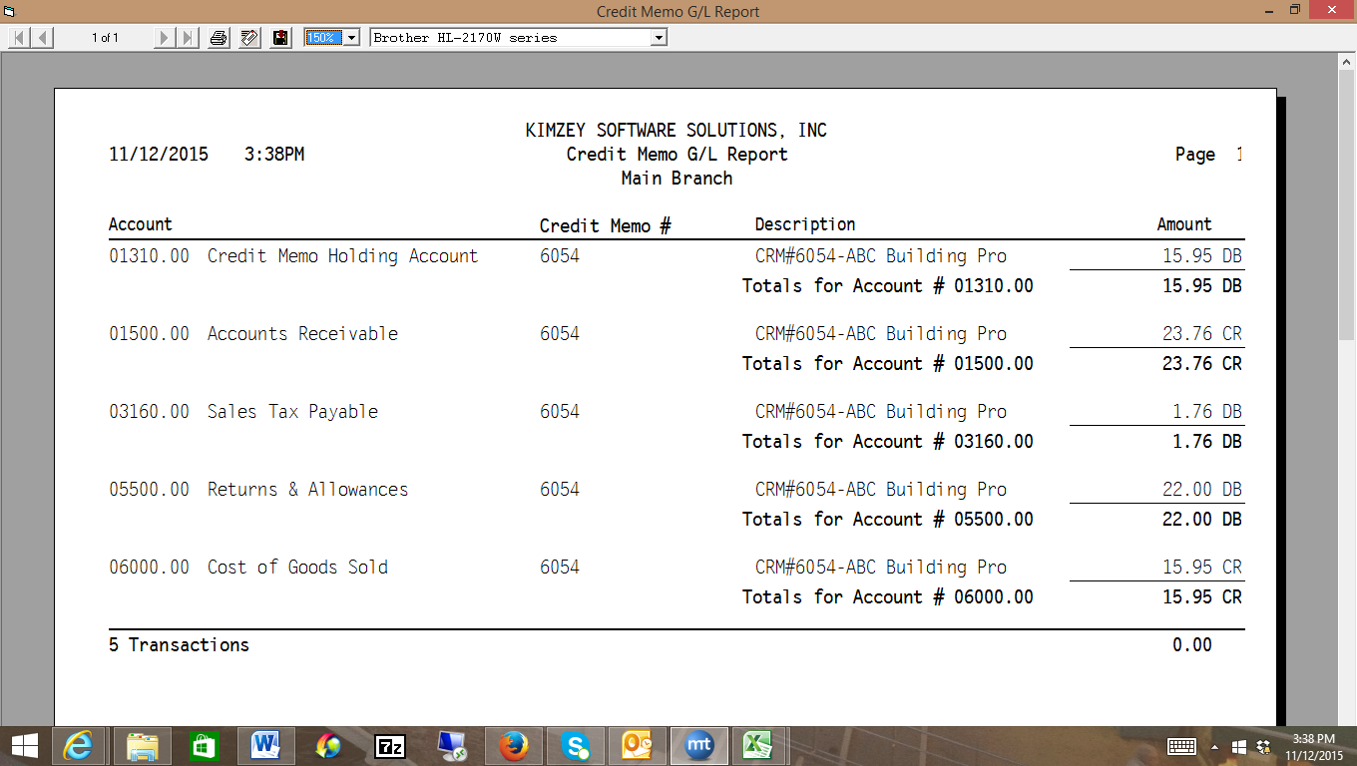
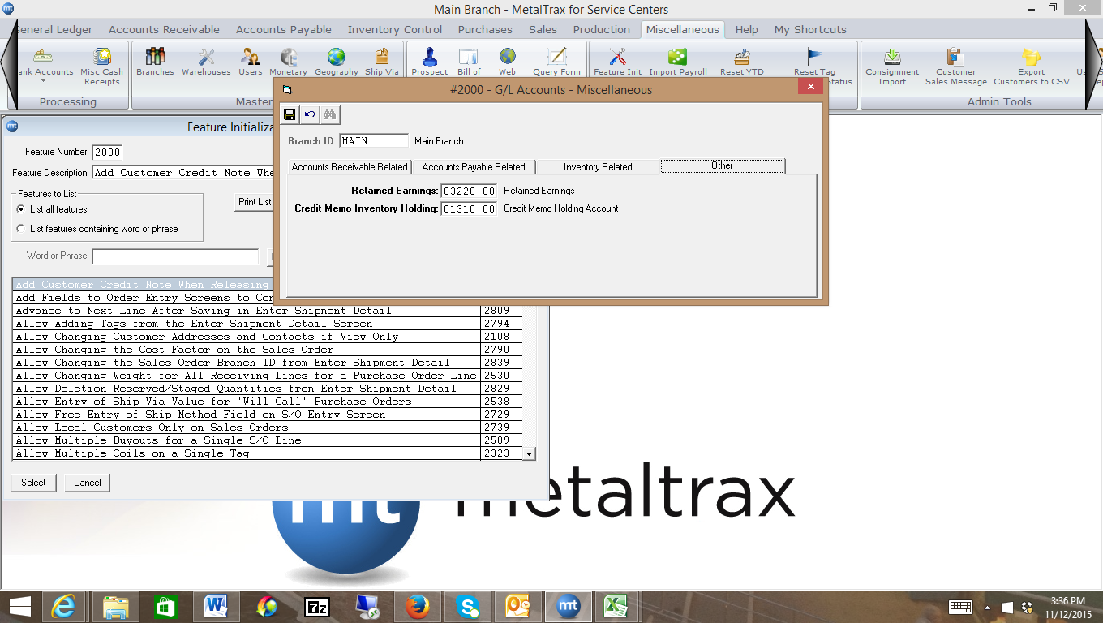

It’s now time to add the inventory back in, due to the fact we had the feature initialization 2745 set to no. So, we’d go into the Inventory Inquiry, pull up the item id BR1-015. I’m going to add a tag for 3 pieces at .40/lb. When prompted for the offset account, you should type in the credit memo holding account found in feature 2000. The system will debit the inventory asset account (1250) for $15.95 and credit the credit memo holding account for $15.95. Notice, when I added the tag back in, I actually clicked on the Enter Ext Cost and typed in the cost of $15.95, to match the credit memo. If I don’t do this, there’s a chance that the inventory I shipped may be an actual weight, and if I add the inventory at a different weight, like the theoretical weight, it may vary slightly from the credit memo. If I click on Ext Cost, then it will be exact.
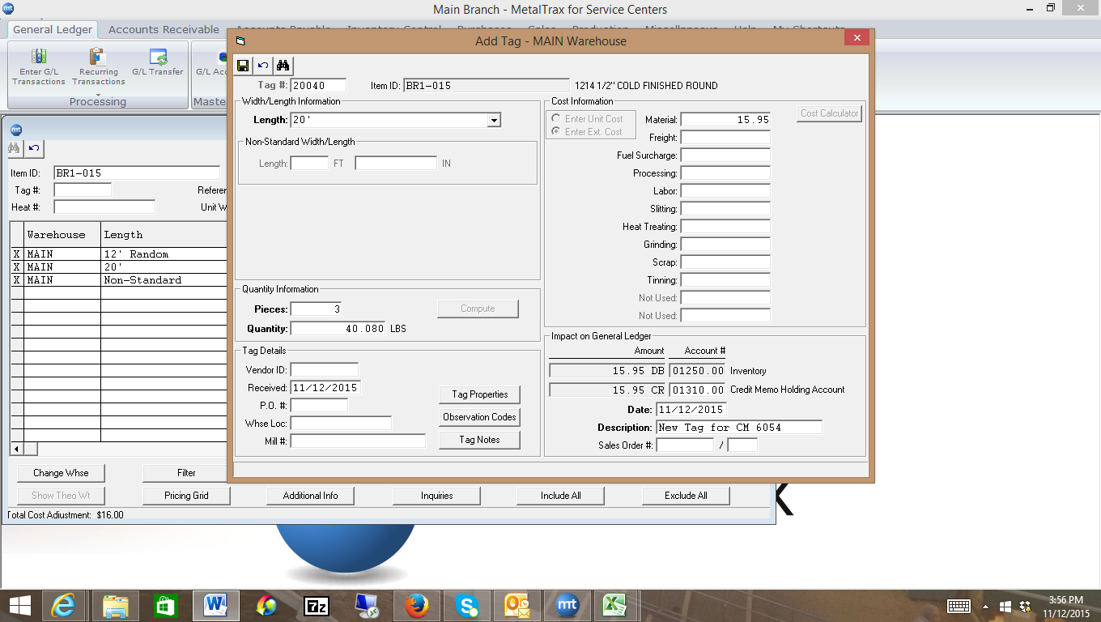
Entering a Payment from a Customer
Let’s receive in a payment for $1,000 from customer ABC.

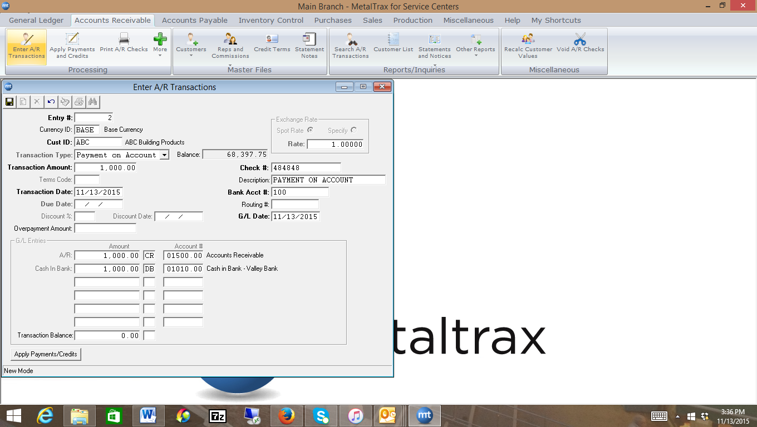
When we post the receiving, Metaltrax debits the Cash in Bank Account (1010) and credits the Accounts Receivable.
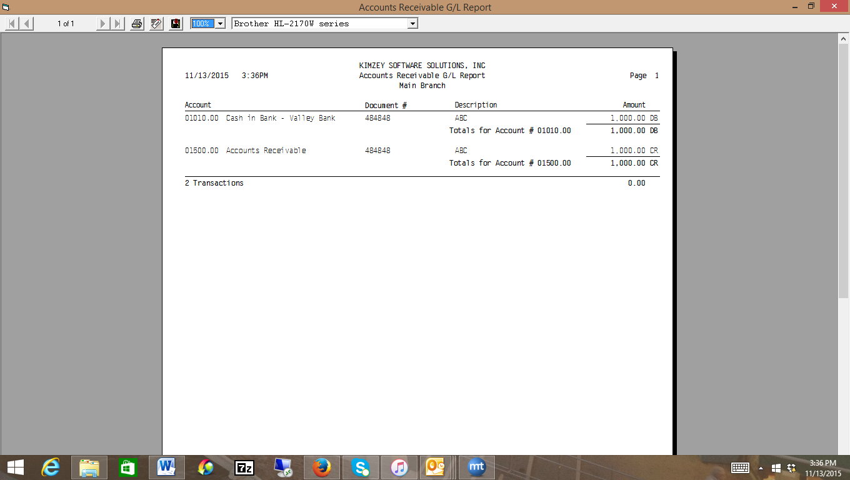
Now, if there is a customer invoice for $879.08 and the customer only sends in $879, you may want to just write-off the .08. Here’s what happens on the accounting side.
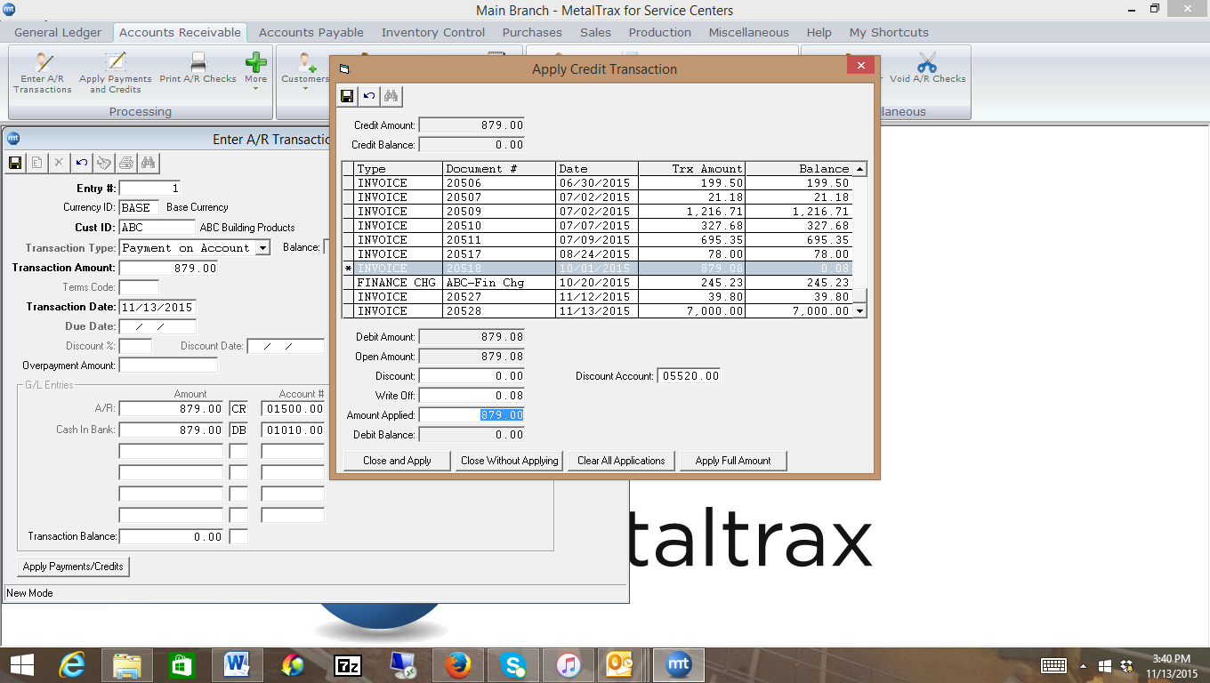
Metaltrax debits the Cash in Bank (1010) for $879, credits the Accounts Receivable for $879 (1500) for the invoice and then credits the Accounts Receivable (1500) for .08 and debits the A/R Write-offs accounts found in feature initialization 2000 under the Accounts Receivable tab for Write-off Expense.
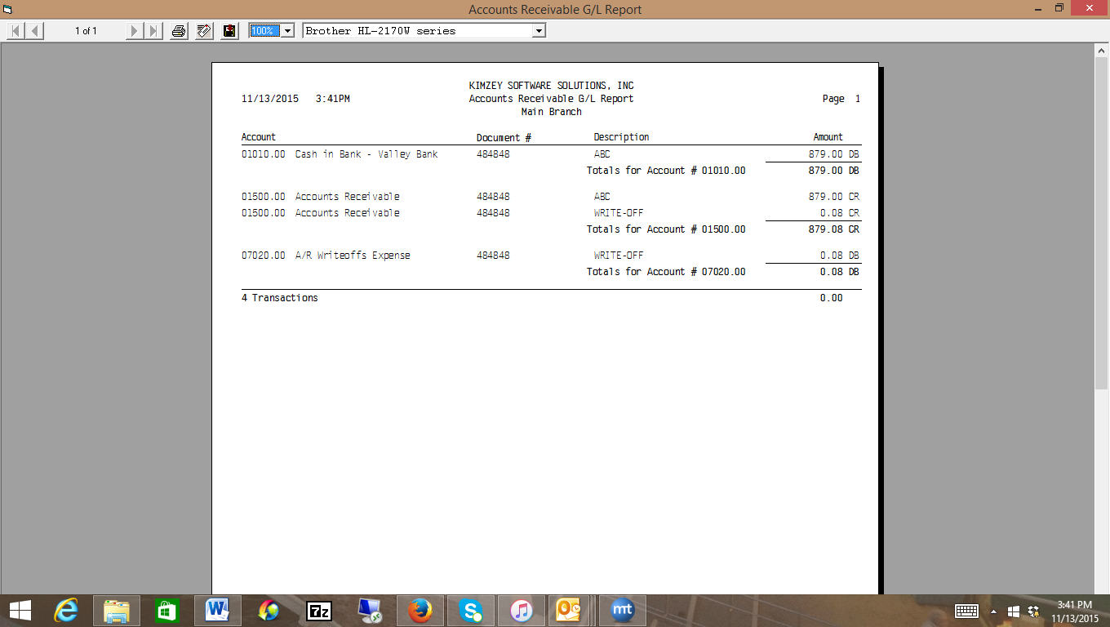
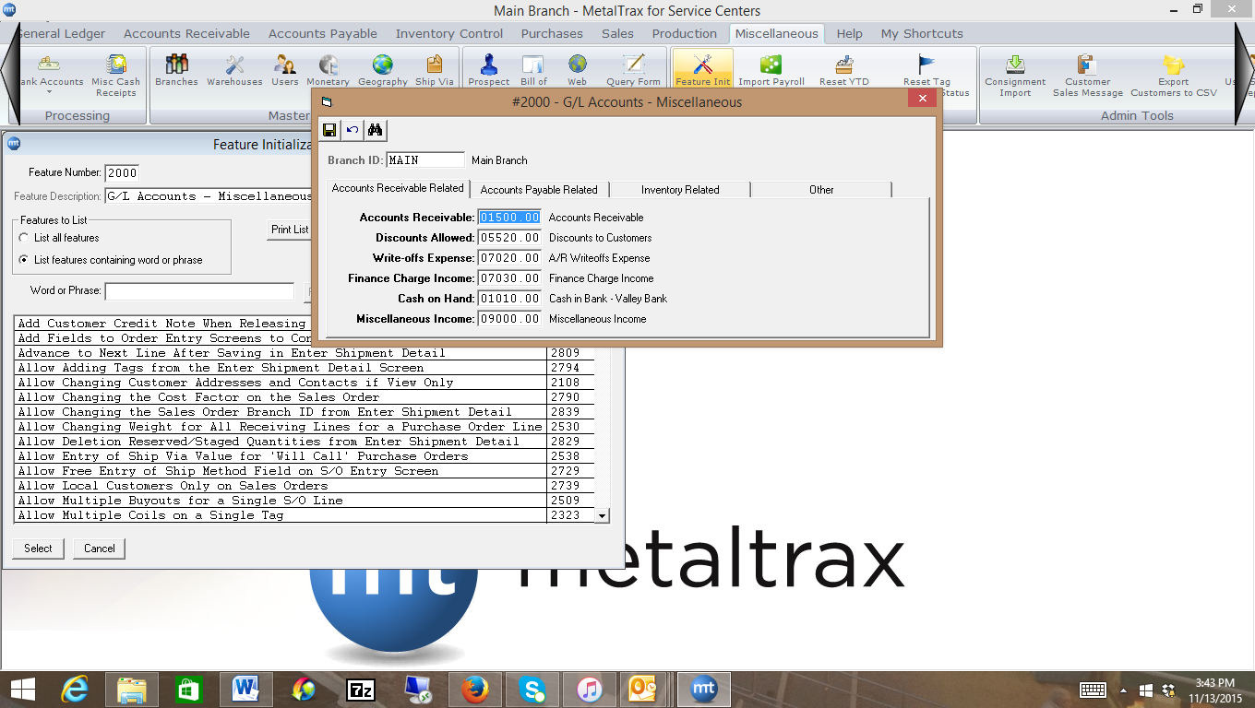
NSF (Non-Sufficient Funds) checks
When you input a customer payment, we’ve shown that the system debits the Cash in Bank Account and credits the A/R. So, if the customer’s check is returned you’ll need to go into A/R Enter Transactions and put in a Debit Entry to Accounts Receivable, with the offset being the Cash in Bank Account. That will allow you to keep track of the original entry, but now the Invoice (Debit) will show back as due. Notice, when I input the NSF, I put the original invoice # in, but I noted in the description that there was an NSF check. This is not necessary, but may be a good idea if you want to keep track of exactly what happened. Notice, because a credit to the Cash in Bank account (1010) is not a normal entry from the A/R, it is asking if you want to create an entry in the Bank Register to reflect this transaction. You would want to click “Yes” to this question.
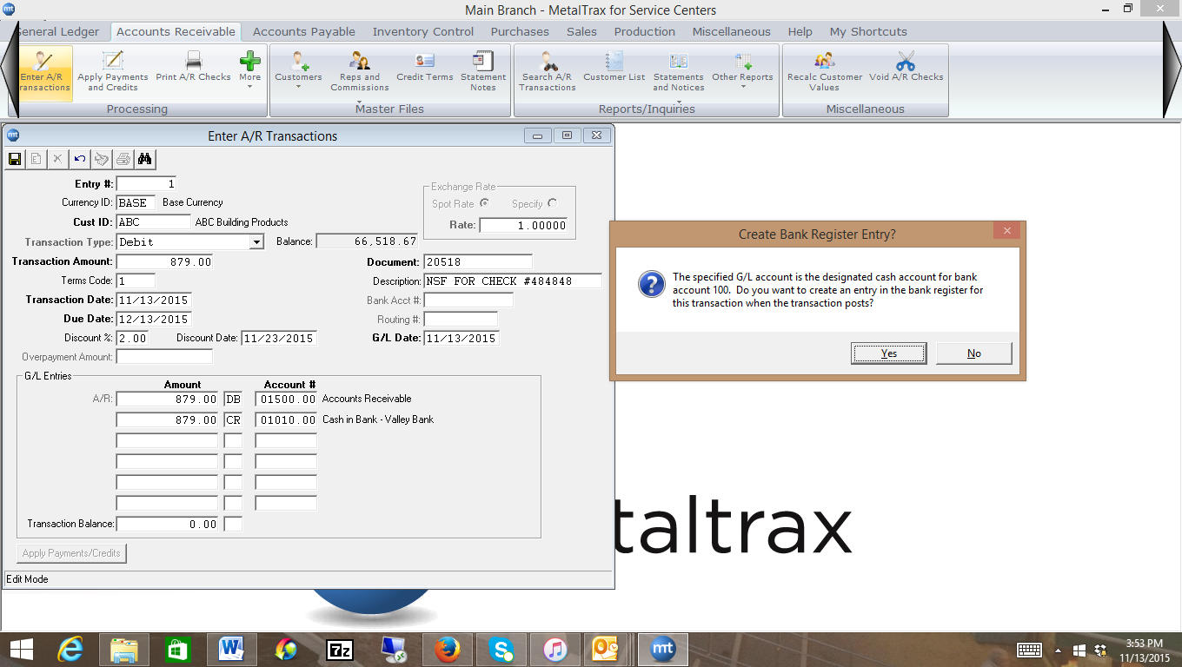
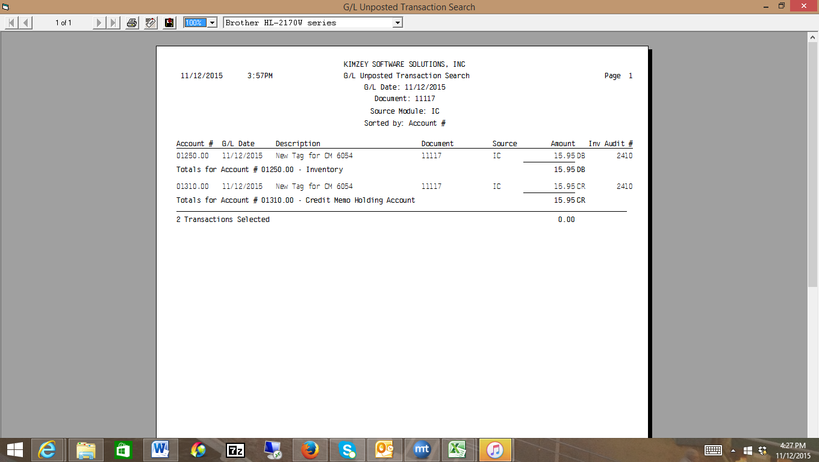

All of these post through to the G/L unposted file. At the end of the day, I can go into the G/L and print my unposted G/L file. The ending balance should always be zero. Once I review the G/L unposted, I can then go into the G/L, Enter Transactions screen and post the G/L unposted transactions. At that point, the G/L Transaction file (GLTRANS.DAT) is updated and the financials will be updated at this time.
