1. Make sure the .RDP shortcut is set to share local printers.  
    Right click  
    Edit  
    Local resources  
    Printers (checked)  
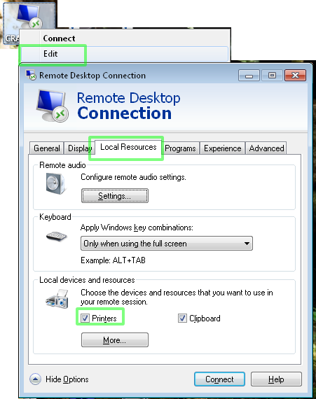  
  
2. On the RDP/Terminal Server, set up a *dummy* printer using the same Print Driver as the Local printer you want to share.  
    This is necessary to keep the print driver resident on the server.  
    If the local printer is an HP Office Jet Pro 1860, you'd add a disabled HP Office Jet Pro 1860 on the Server and give it a name like "Dummy printer, do not delete."  
    If the print driver is not already in the list, you may need to download it onto the Server so you can pick it from the "Have Disk" option.

